This problem will be worth 12 points. There is the one student tester and 10 additional tests for a total of 11 tests. A twelfth bonus point will be awarded for correctly implementing all methods in this class.

This problem will ask you to implement the following functions. One function is defined recursively. Other times I will give you functions from the java.lang.Math with a brief description, and some times you just need to implement the function. In all the following functions you do NOT need worry about domain issues. That is, you may assume that all test data will not cause any exceptions to be thrown. In total, there are ten different functions in this problem. Each successfully implemented function will earn you a point. Complete all 10 and you will earn a bonus (twelfth) point from this problem. Except for the first method and all Boolean methods, all methods will return a double. Your method must return value within 0.05 of the correct answer to be considered correct.

You should use:
- Math.abs(x) for |x|
- Math.sqrt(x) for 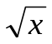
- Math.pow(x, 1./n) for 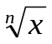
- Math.log(a) for 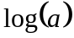
- Math.log10(a) for 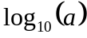
- Math.cos(a) for cos(a)
- Math.sin(a) for sin(a)
- Math.tan(a) for tan(a)

- Implement the following recursive function.
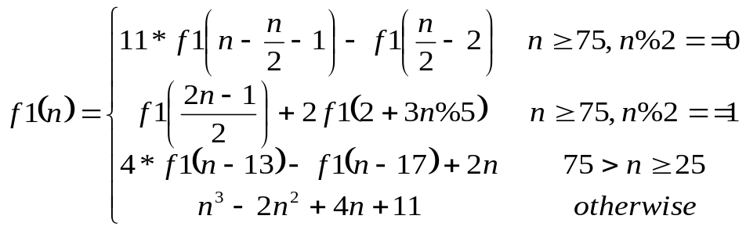
using the following function heading:
public static int f1(int n)

Test data: f1(12) returns 1499

Note: The correct call to a recursive static method is of the form:
MoreFunctionsGoneWild.f1(n)

- Implement the following rational function.
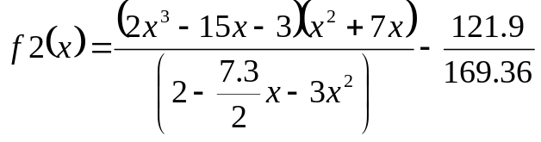
using the following function heading:
public static double f2(double x)

Test data: f2(10) returns -939.4043724

- Implement the following function.
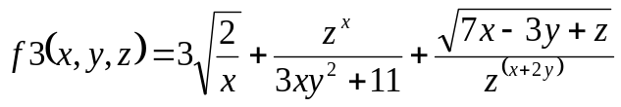
Use the following function heading:
public static double f3(double x, double y, double z)

Test data: f3(50, 1, 1) returns 19.26097

4. Implement the following function
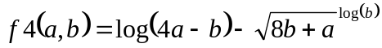, 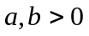
Use following function heading:
public static double f4(double a, double b)

Test data: f4(1, 1)) returns 0.0986123

5. Implement the following function
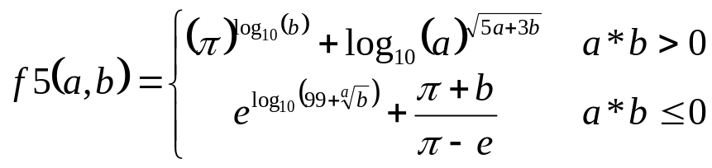
Use the following constant for both pi and e
Math.PI | The double value that is closer than any other to pi, the ratio of the circumference of a circle to its diameter.
Math.E | The double value that is closer than any other to e, the base of the natural logarithms.
Use following function heading:
public static double f5(double a, double b)

Test data: f5(1, 2)) returns 1.41142
f5(-1, 2)) returns 19.5191285

6. Implement the following function
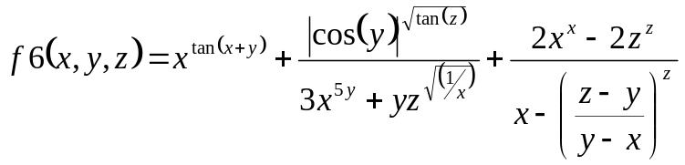

Use following function heading:
public static double f6(double x, double y, double z)

Test data: f6(1, 2, 1) returns 1.066968

- Implement the following function
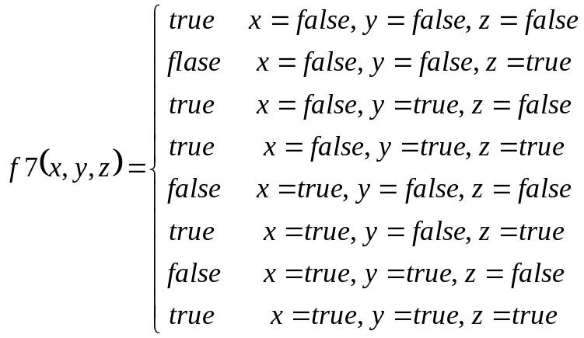
Use following function heading:
public static boolean f7(boolean x, boolean y, boolean z)

Test data: f7(false, true, false) returns true

- Implement the following function
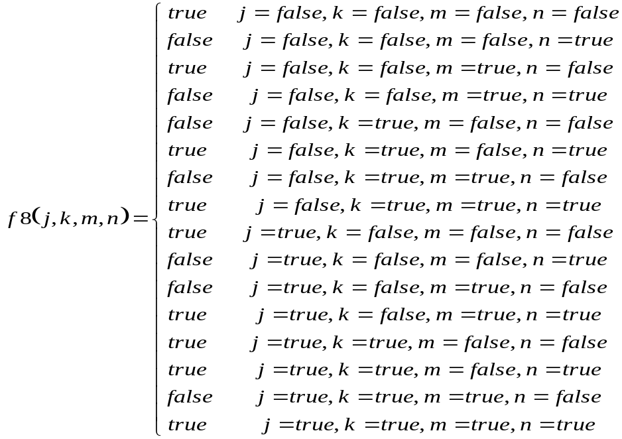
Use following function heading:
public static boolean f8(boolean j, boolean k, boolean m, boolean n)

Test data: f8(false, true, false, true) returns true
- Implement the following function
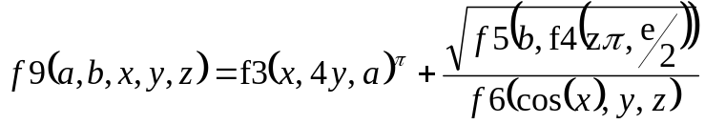
Use following function heading:

Recall Math.PI and Math.E are constant that should be used as for the values π and e.

public static double f9(double a, double b,
double x, double y, double z)

Test data: f9(5.69, 2.37, 5.03, 0.85, 4.11) returns 75997.8079512

- Implement the following function
Use following function heading:
public static boolean f10(boolean a, boolean b, boolean c, boolean d)

Test data: f10(false, false, true, false) returns false

Each of the above functions is tested individually. Each function that is correctly implemented will earn one point. An eleventh bonus point for correctly implementing all ten functions will be awarded!

